The Guardian

Tue 12 May 2026

Denis Campbell Health policy editor

Arts and cultural engagement ‘linked to slower pace of biological ageing’

Research from University College London suggests visiting art galleries or museums, singing and painting can help improve health outcomes

Singing, painting or visiting a gallery or museum helps people age more slowly, according to the latest study to link taking an active interest in art and culture with improved health.
The findings are the first to show that both participating in arts activities and attending events, such as viewing an exhibition, lead to people staying biologically younger.
“These results demonstrate the health impact of the arts at a biological level.
They provide evidence for arts and cultural engagement to be recognised as a health-promoting behaviour in a similar way to exercise,” said Prof Daisy Fancourt, the lead author of the research and the head of the social biobehavioural research group at University College London.
However, slower ageing does not necessarily mean someone will live longer. The “epigenetic clocks” used in the study to assess biological ageing are predictive of future morbidity and mortality, and previous studies have suggested a link between arts engagement and longer lifespan, but much more research would be needed to establish potential causal effects on longevity.
Those who take part in artistic pursuits the most often slow the pace of their biological ageing the most. Under one of the study’s methods of assessment, those who did so at least weekly slowed their ageing process by 4%, while monthly engagement led to it slowing by 3%.
Similarly, another of the tests showed that those who undertook an arts activity at least once a week were on average a year younger biologically than those who rarely engaged in such pursuits. Those who exercised once a week were only six months younger by that measure.
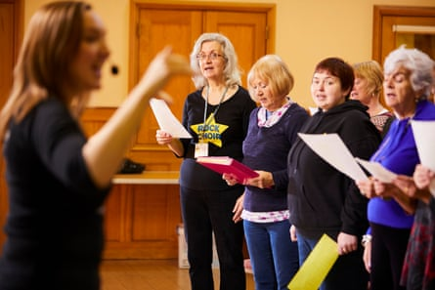
Participants in the research were also asked how often they took part in singing, dancing, paint, photography or crafting. Photograph: Christopher Thomond/The Guardian
The benefit the arts confer on the pace at which people age is so dramatic that it is comparable to the difference between smokers and those who have given up smoking, the researchers say.
“Our study provides the first evidence that arts and cultural engagement is linked to a slower pace of biological ageing,” said Dr Feifei Bu, a senior author and also a UCL academic. “This builds on a growing body of evidence about the health impact of the arts, with arts activities being shown to reduce stress, lower inflammation and improve cardiovascular disease risk, just as exercise is known to do.”
The results, published in the journal Innovation in Aging, are based on blood test and survey response data from 3,556 adults taking part in the UK Household Longitudinal Study. It uses blood samples to estimate people’s biological age and the pace at which they are ageing.
Participants were asked how often over the last year they had taken part in singing, dancing, painting, photography or crafting, or had attended an art exhibition or event, visited a heritage site such as a monument or historic building or park, or been to a museum, library or archive.
“Many of us know instinctively that taking part in creative and cultural activities is vital for a happy, flourishing life,” said Hollie Smith-Charles, the director of creative health and change programmes at Arts Council England. “These impressive new findings are further evidence that arts, museums and libraries help us live well for longer, and demonstrate how vital it is that everyone, everywhere has access to excellent and affordable culture on their doorstep.”
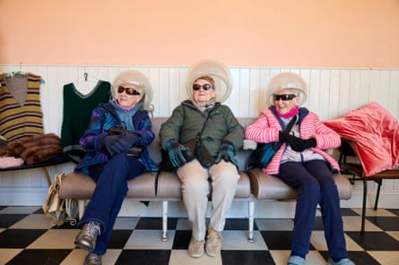
Three women enjoy an exhibit at Beamish, The Living Museum of the North, in County Durham. Photograph: David Levene/The Guardian
Evidence is emerging that the arts can improve both mental and physical health. In 2019 the World Health Organization published a report, by Fancourt and Saoirse Finn, which highlighted initiatives such as playing music to patients before surgery and using the arts with people with dementia.
In the latest study, the middle-aged and older adults aged 40 or above received the biggest boost to the pace at which they aged as a result of taking part in the arts.
“Across the arts sector we have known for a long time that getting creative yields extraordinary benefits for our health, and this latest research adds a vital new piece to the puzzle, proving that arts and culture can even slow down the biological clock,” said Mark Ball, the artistic director of the Southbank Centre, a multi-arts venue in London.

